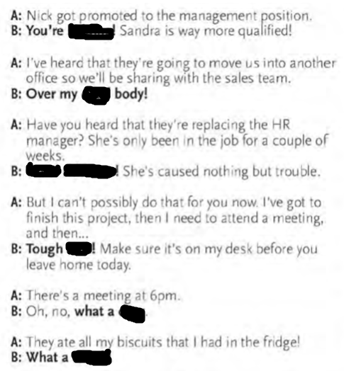

**Kidding , goodness me , luck , cheek , drag , dead,**

**Kidding, dead body, goodness me, luck, drag, cheek**

Where shall I put it …dump put……………………….it anywhere

Havey outaken decision I am having …………second………….thoughts

Do you remember his name It’s on the …tip………………of my tongue

It looks a bit expensive This is …on……………………me

Can I have some more meat? …Help……………………….. yourself

Can I use your phone ? Be my ……guest……………………

I have got some bad news I am all ……ears……………………

I can’t give you a hand Ok thanks all the…same………….

My stomach hurts Serves you …right…………………..

I am going to club …Suit…………………yourself

Can you pass it I can’t be …bothered………………….

I will become a superstar That will be the day………………

Where were you last night? Mind on……………..your own

business